EventApp - SOA

*Microservice architecture*

Microservices is an approach focusing on decomposing large applications into separate pieces that can work together. Each service is responsible for a specific function and having its own implementation for business logic and connection to the database. (Figure 1) They can handle many tasks, but all of them concerning one single function. Since the services don’t know about each other implementation it makes it easier to test, deploy and maintain them. Communication between services is done through REST Template using HTTP protocol’s methods: GET, POST, PUT, DELETE [1].

*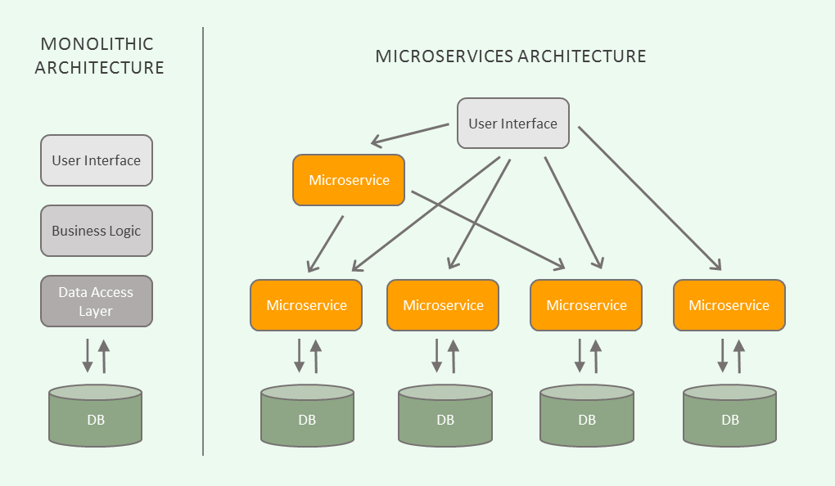*

*Figure 1 –microservice architecture [2]*

EventApp was developed as a web application that follows a client-server model: Spring Web Architecture. The main idea of client-server model is that the client sends a request through internet, the server process it and sends back to the client a response. This architecture allows the server to handle multiple clients in the same time and also a single client can connect to many servers.

The server is composed of two independent microservices that manages different functions in the application. Each microservice is a distinct project having its own implementation, business logic and database. Even though they don’t know about each other’s implementation, they work together like a big server that can be accessed by the client-side application. (Figure 2) Login Microservice is responsible of managing the existing users (client, lawyer, admin) including authentication and registration. The Main Microservice handles the main features of the application regarding the events. It communicates to Login Microservice through web APIs in order to get information about the users when needed.

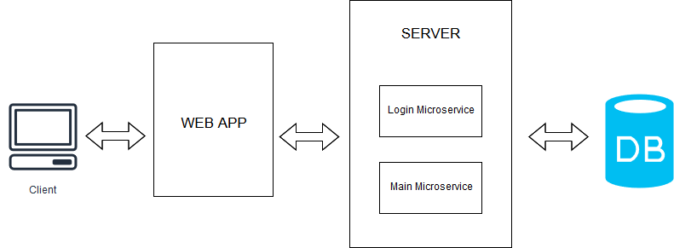

*Figure 2 – system diagram*

Bibliography

[1] – Microservices with Spring Boot — Intro to Microservices (Part 1); Online: https://medium.com/omarelgabrys-blog/microservices-with-spring-boot-intro-to-microservices-part-1-c0d24cd422c3;

[2] – Introduction to Microservices; Online: https://blog.algorithmia.com/introduction-to-microservices/;